**Wind-up: Our proposition**

**Challenge:** Your challenge is to create a sensor (or cluster of multiple sensors) to be used by humans on Mars.

Aim: To track human movement using a mixture of wearable sensors and wall mounted sensors inside habitats

Benefits:

- Record and analyse human movement

- Assess health

- Assess ergonomics of habitat and equipment

**Hurdle: Current Problems**

1. No data on effects of Mars’ low gravity on humans

o Reduction in bone density

o Muscle degradation

o Changes in physiology (bad posture, inability to lift heavier weights, muscular tension, changes in walks etc)

2. Change in physiology before, en route and after arriving on Mars

3. Inexperience of optimization of Martian living space

4. Unknown development of physical health problems

**Vision: Our solution**

Designing a second skin layer which can be worn as an undersuit. This suit would be lined with multiple motion sensors which will detect human movement, from this we can learn about the changes in human physiology in the martian environment over a period of time, but also help us analyse day to day tasks. Using this data we can do things such as refining daily actions to improve work efficiency, detect small injuries before they become worse, maintain fitness.

**Alternative options**

1. Consistent exercise routine (used on ISS to reduce muscle mass degradation and bone density degradation)-

o

2. Theoretical option – Centrifuge for the journey -

o

3. Tensioned suit -

4. Using the medical sensors they use on the ISS - Currently on the ISS they use



5. Using external cameras like they use in animation - less details and powerful cameras needed all over habitat; wouldn’t work outside in a spacesuit.

o

**Close: Delete other options**

1. Consistent exercise routine /subject loading devices

* Different g
* Different workload for Martians compared to ISS astronauts
* Martians may need not need as many hours of exercise so they can have time for other things.

Constant tracking might save time by allowing the astronauts to work out less than in ISS

2. Theoretical option – Centrifuge for the journey

* Cost too much
* Still only a theory
* Not viable

Several problems including coriolis effect, and incredible costs

3. Tensioned suit/GLCS Gravity Loading Countermeasure Skinsuit

* Could be a valid option, although movement tracking could be used to approve or disprove it
* Could cause issues with blood circulation
* Potential for overheating.

o

4. Stretching/Massaging

* Time consuming
* Needs specialist attention
* Only a short term solution

5. Using external cameras and reflective suits

* Using external cameras is not an option for tracking human movement outside the habitat
* High quality cameras would be needed throughout the habitat.

Constant energy and processing use to determine location

Extra external clothing requirements as opposed to an undergarment

6.Lower body negative pressure

* Very large and cumbersome

**Fine Print: How it works** 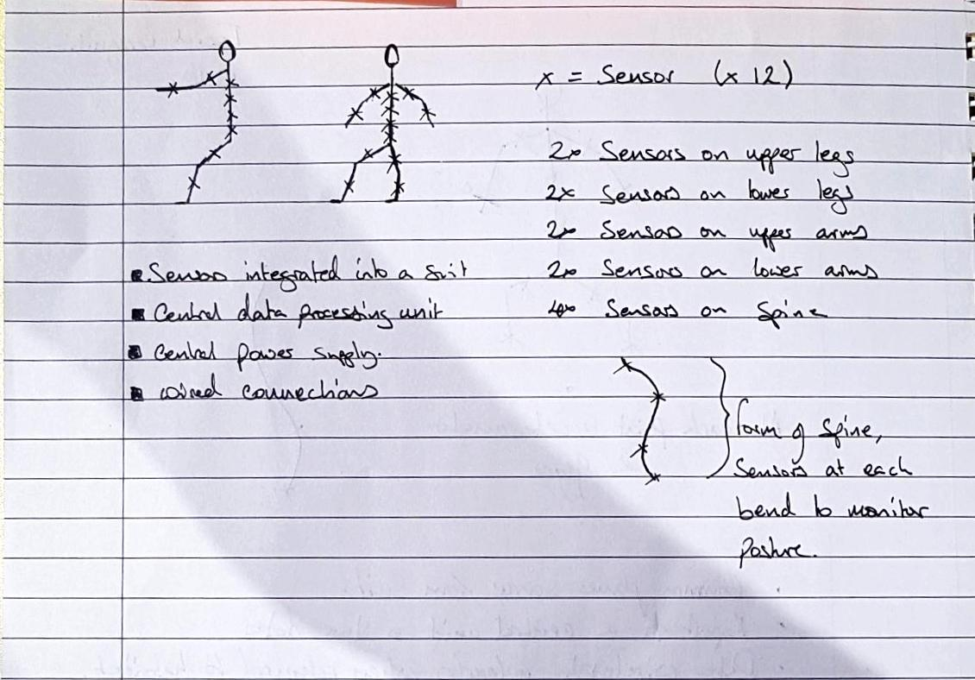

**How does it work?**

Visual Description - A skin tight suit containing 16 sensors at key joints along the body, a control unit and a power supply. Sensors are positioned, 1 for each lower limb, 1 for each upper limb, and 4 along the length of the spine, see positioning of the ‘x’ marks on the stick men.

The Sensor - Each sensor will be comprised of an accelerometer and gyro, this mean that for each point on the body, orientation and directional movement can be determined (angle to reference, velocity, acceleration). Example sensor dimension (4.1mm x 4.1mm x 0.95mm, MPU-6050). [hobbiest level equpment] <https://datasheet.octopart.com/MPU-6050-InvenSense-datasheet-21631037.pdf>

Communication - Sensors will be coordinated by a central controller (by wired connections) that will manage sensor output, data storage and wireless communication to a computer system.

Power - The sensors and controllers will all run from a central power supply, this means that the weight of the system can be kept closer to the users body and means that sensor units will be less intrusive. The GT1M is lightweight (27 g), compact (38mm × 37 mm × 18 mm) [Military level equipment]

“Recognition of Military-Specific Physical Activities With Body-Fixed Sensors, Thomas Wyss , MSc ; Urs Mäder , PhD”

**How does our project fulfill the success criteria**

1. Impact

* Large impact because it solves a long term problem which if left unsolved could limit the working lifespan of a Martian. Help all Martians but also has very practical Earth uses/applications

2. Creativity

* Innovation rather than invention. Using existing technology in a creative way to solve new problems. The tech is used on Earth but for a different purpose. We are gathering data on a problem that was never explored before

1. Validity

* A similar system has been used by Ford to collect data on how their employees are working on a production line, they used this data to improve work stations to reduce the stress on their bodies over a long shift. [Reference](http://www.dbusiness.com/daily-news/Annual-2018/Dearborns-Ford-Uses-Body-tracking-Technology-to-Make-Workstations-Less-Physically-Stressful/)

1. Relevance

* Responds to the challenge well. The idea is a proven model, we possess the skills to do it, it would just require funding and appropriate time allocation. Very technically feasible, as a lot of the used technology already exists. The project is very friendly, it integrates with daily usage items of an astronaut so it requires no extra work, in fact the system is designed to help mitigate risk of physical injuries over a long period of time as well as helping in optimization of the habitual living quarters as some areas are under/over utilized
* This project would be fully utilised by making the assumption that the Martian habitats are modular and are designed with the intend to be modified after compiling data from both components of our system..

1. Presentation

* Communicate project effectively
* Explain the Challenge, the solution and why it’s important
* Explain the journey and thought process behind the reasoning for choosing of the project
* mEANS THE REQUIREMENT OF HAVING AN ONBOARD DOCTOR IS LOWER SINCE THE DEATA THEY’D NEED CAN BE SENT BACK TO EARTH AND ANALYSED BY A DOCTOR ON EARTH.

**Any way to calculate a rough estimate of costs?**

**Potential questions from Judges**

Questions from Judges (from one of the judges):

* Business perspective of the project
* Academic perspective
* Considerations for Global judging